JENNIFER E. MICHAELS

ARTIST STATEMENT

In the Beginning God created... Since we are made in God's image, we are born to create too. Each of us has unique ways in which God wants to partner with us to create something beautiful in our lives. It may be through visual arts, literature, music, theater, preparing food, decorating, gardening, charities, businesses, relationships, etc... Each new breath is an opportunity to Co-Create with the Bright White Light in our Life and watch the miracles happen.

I have been an artist from the day I was born. Although I have struggled over the years with resistance to the process, without fail, my journey through life has routinely brought me back to the one thing that brings me peace… Co-Creation. Today I am a full-time Artist, Author, Healer, Speaker and Spiritual Life Coach. I am committed to creating work from the perspective of being a vessel for God. I believe there is nothing more important than moving gently in the direction of our creative dreams. Creativity is the bridge that makes the unconscious conscious, heals the soul, expands self-love and inspires global unity.

The process I use and teach is creation through meditation.

Thank you for looking at my work.

Love,
Jennifer

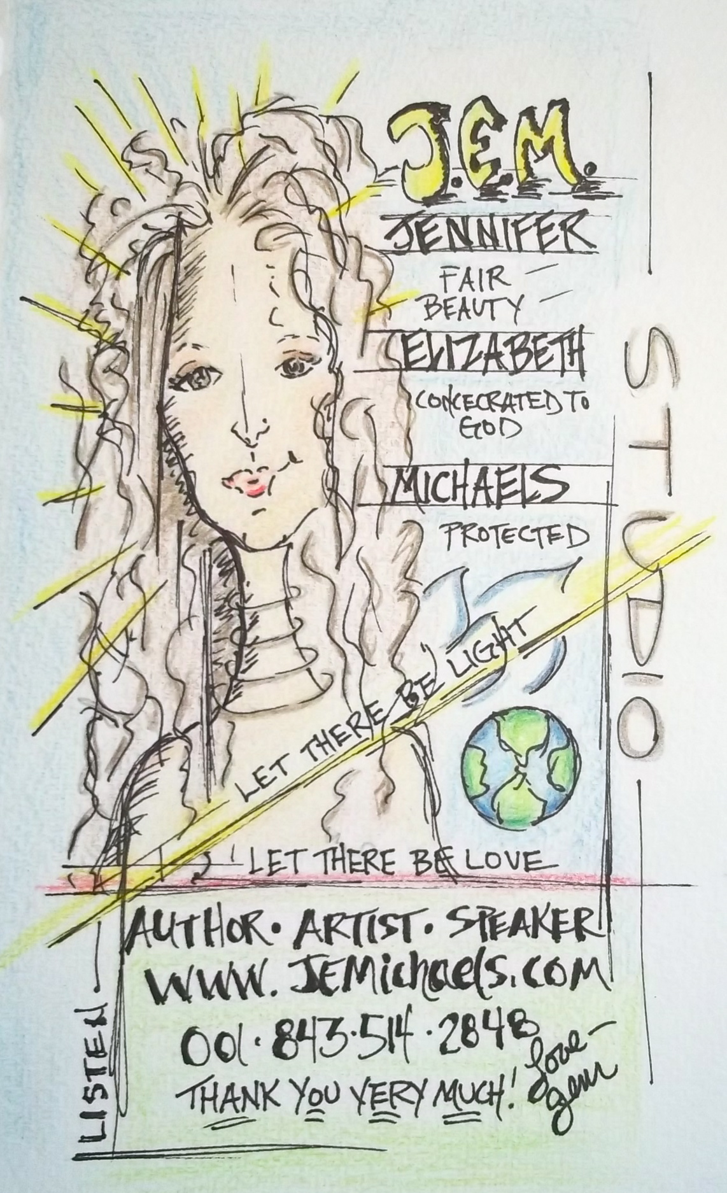
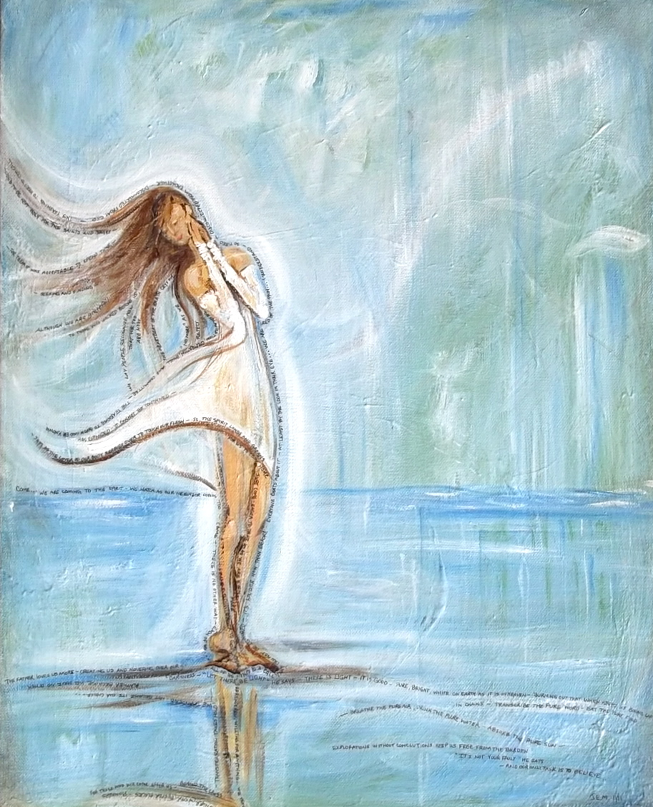

725 Coleman Blvd. 408, Mt. Pleasant, SC 29464 / Jennifer@jemichaels.com / www.jemichaels.com/ 843-514-2848

